Foschia & Co
Championship rings
____________________________________________
2021 slo-pitch ontario
SPO – SQUARE |  | SPO - ROUND |  | SPO - BAND |  | SPO - LADIES’
Sterling Silver | White Lustre | Sterling Silver | White Lustre | Sterling Silver | White Lustre | Sterling Silver | White Lustre
$225 | $165 | $225 | $165 | $145 | $110 | $135 | $100
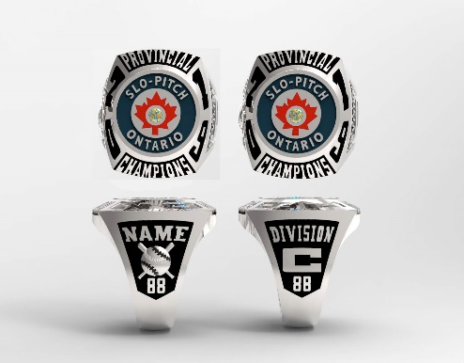 |  | 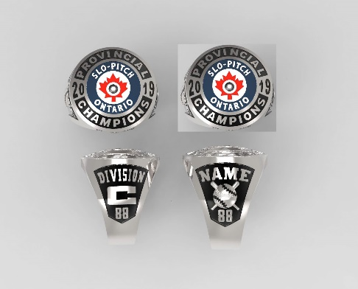 |  | 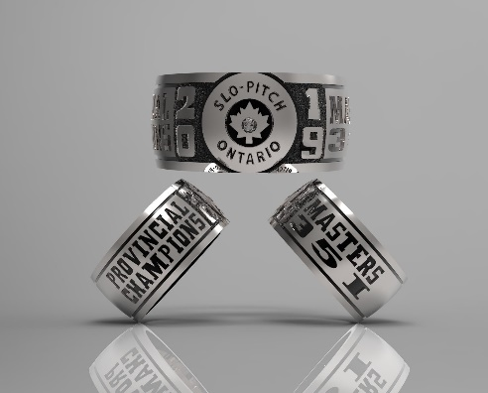 |  | 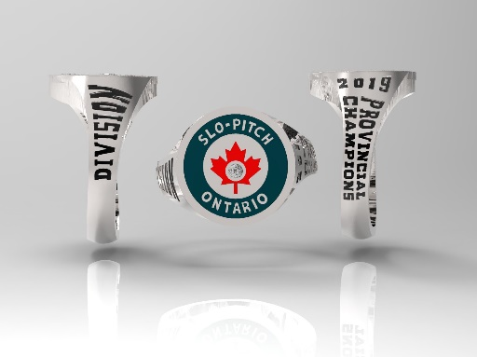

Please submit completed order form to foschiaandco@gmail.com. The TEAM CONTACT will be notified to verify the order and given a total including shipping and HST. A deposit will be be required to start the order. A shipping cost will be determined using the shipping address on the form. Please direct any questions to Ann-Margaret Foschia at foschiaandco@gmail.com.

TEAM NAME |  |  |  |  |  |  | DIVISION
TEAM CONTACT |  |  |  |  |  |  | PHONE
EMAIL

*ALL RINGS SHIPPED TO ONE ADDRESS ONLY*
STREET ADDRESS FOR SHIPPING:

CITY /PROVINCE/POSTAL CODE:

INITIAL | LAST NAME |  | JERSEY NO. | FINGER SIZE | STYLE – Please check one |  |  |  |  |  |  | METAL  Please check one
 |  |  |  |  | SQUARE | ROUND |  | NAME ON RING  MAX. 9 CHARACTERS  *SQUARE & ROUND STYLES ONLY* |  | BAND | LADIES’ | SILVER  S.S. | WHITE LUSTRE  W.L.

